**Newsletter August 2024**

**Autumn Vaccination Campaigns:**

**The Surgery is running a variety of vaccination campaigns. We will contact those who are eligible to book these appointments.**

**RSV Vaccine** [**RSV vaccine for adults (publishing.service.gov.uk)**](https://assets.publishing.service.gov.uk/media/668eb423fc8e12ac3edafa9d/UKHSA_12949_RSV_vaccine_for_adults_14_WEB.pdf)

What is RSV?

Respiratory Syncytial Virus (RSV) is an infectious disease of the airways and lungs causing symptoms like a cold and the flu. It can also make you become wheezy or short of breath and lead to pneumonia. Every year thousands of older adults need hospital care for RSV and can be more severe in people with medical conditions such as heart or lung disease or a weakened immune system.

How do you catch RSV?

RSV infections can occur all year round, but cases peak every winter. RSV can spread through coughs and sneezes. You can help to prevent the spread of the virus by covering your mouth and nose when you cough or sneeze and you can wash your hands frequently to reduce the risk of picking up the virus. Even with these measures it can be difficult to avoid RSV infection so the best way to protect yourself is to have the vaccine.

How does the vaccine work?

Almost all older adults will have had several RSV infections during their life. A single dose of vaccine will help to boost protection as you reach an age group at highest risk of serious RSV infection.

Are there any other people eligible for the RSV vaccine?

Pregnant women are also being offered the vaccine to protect their babies from RSV.

[**Respiratory syncytial virus (RSV): maternal vaccination - GOV.UK (www.gov.uk)**](https://www.gov.uk/government/publications/respiratory-syncytial-virus-rsv-maternal-vaccination)

**Shingles Vaccine Shingles vaccine - NHS (www.nhs.uk)**

The shingles vaccine helps protect against shingles. It's recommended for all adults turning 65, those aged 70 to 79 and those aged 50 and over with a severely weakened immune system.

Some patients require a 2-dose course of the shingles vaccine. If you require this second dose, we will contact you to book this appointment.

**Covid and Flu Vaccines**

The Autum Covid and Flu rollout is due to start in Early October. We will contact eligible patients nearer the time to arrange their appointments.

**Repeat Prescriptions whilst you are on holiday**

If you are registered with Atlantic Medical Group and are on holiday or away for work and find you are running out of your medication you can still obtain it from a pharmacy in that area. You can call the surgery on 01736 363741 or 01736 788306, press option 3 and speak to a member of our dispensary team.

We can request your medication be sent to a pharmacy close to where you are staying as long as it is a pharmacy in England. If you are staying in Scotland, Wales or Northern Ireland and need medication urgently you would need to register as a temporary patient at a surgery in that area or contact the Out of Hours Team on 111.

Please note that whilst Wales and Scotland offer free prescriptions to their patients, as your address is in England you may be charged for your prescription.

**Insect Bites and Stings**

Insect bites and stings are a common complaint at this time of year and in most cases, they can be treated safely at home.

In the first instance you can treat the area at home by removing the sting if you are able, wash the area with soap and water and apply a cold compress to reduce swelling. If these home remedies are not helping you can attend a pharmacy to obtain over the counter relief such as creams, painkillers or antihistamines.

Tick bites are harder to spot and need to be removed with an appropriate tick removal tool. If you have access to one of these and attempt to remove it yourself, ensure you grasp the tick as close to the skin as possible, pull upwards slowly and then clean the area with an antiseptic.

**If you begin to experience worsening pain, reddening, swelling, a fever, swollen glands or flu-like symptoms contact the GP.**

**If you feel faint or dizzy, experience swelling in the face or throat, have trouble breathing, or any other worrying symptoms, please call 999 without delay.**

[**Bitten or stung by an insect? How to treat yourself at home and when to seek help - NHS Cornwall and Isles of Scilly (icb.nhs.uk)**](https://cios.icb.nhs.uk/2024/08/01/bitten-or-stung-by-an-insect-how-to-treat-yourself-at-home-and-when-to-seek-help/)





**Keeping Cool in hot weather**

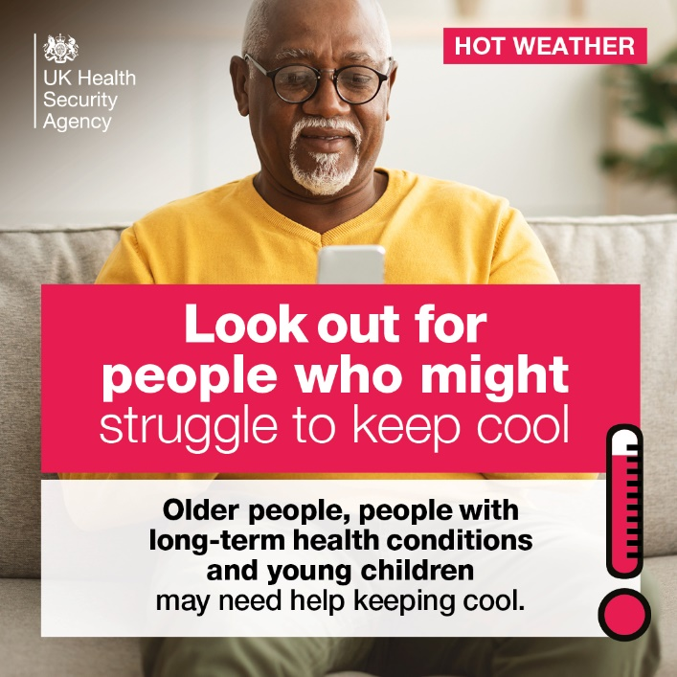With the summer weather finally making an appearance it is important to protect yourself, families and friends from the heat.

If you can, check in on older friends, family and neighbours, particularly those who live alone.  
  
Don’t leave babies, children, older people or vulnerable people or pets alone in the car.  
  
Look out for children in prams or pushchairs; keep them in the shade with plenty of air flow and check them regularly to ensure they are not too hot.

Ensure you are applying sun protection, seeking shade, and staying hydrated, particularly between 12-3pm when the sun is at its highest.

**Patient Transport to Hospital Appointments**

If you have been referred to a consultant at the hospital you may be offered an appointment at Treliske in Truro. We understand that it can be difficult to get to these appointments if you struggle with your mobility, are unable to drive yourself or if a family member or friend is unable to take you.

Please find below the contact details for some services to arrange transport for yourself ahead of your appointment:

Main Transport Booking Service at Treliske: 01872 252211

TAP Cornwall: 01872 223388

Volunteer Cornwall: 01872 265300

Douglas Woolcock (St Just residents): 07899 412060

*Please note: The Douglas Woolcock Charity accept donations for their transport services.*

**